Group No 2

Paras, Gursehbaj, Harpreet Kaur and Prabhjot Singh

Student management System

Customise this document - make this cover your own design

Contents

Executive Summary 2

Design Analysis Process 2

Entity Relationship Diagram 3

Table Designs – Data Dictionary 4

Contributions 5

References 5

# Executive Summary

The **University Student Management System** (USMDS) is a **user-friendly** platform that will not assist academic staff to store and organize student’s information easily in **one place** but also help students to manage their profiles along with high level of security. We understand that how challenging it is, to store the information of the thousands of students and update it frequently when it is required. Therefore, we have made this database to to improve the overall experience for the students, staff members and administrators by utilization of just one centralized system.

By implementing University Student Management System, numerous fruitful benefits will arise that can enhance the overall academic experience:-

1. This system will help students to access their personal data and the academic planning in which they will be able to check their personal information, academic records, enrolment status, course tenure and how much are they paying for it in just one place.
2. This system will also help academic staff to manage course information, grades and enrolment details just by one centralized system. It will also improve the accuracy and consistency across the institute regarding every aspect of students by better allocation of the data in system.
3. This system will play a predominant role for the admin to manage the student information effectively and efficiently. By the utilization of this system, administrators can keep thousands of students’ information in one database and can update it frequently whenever it is required.

To put in a nutshell, USMS is such a great platform that will make the overall process easier and more smoother for the universities to manage the students effectively. And will also become handy for the learners to access all the vital resources throughout their study duration.

# Design Analysis Process

**User stories :-**

**User stories for the Student**

* As a student, I want to update my contact information, including email, address, and phone number, so that I can receive correct information from the college and stay informed about new announcements and important updates without any difficulty. This will assist to stay connected with my studies if I am not able to attend lectures in any emergency.
* As a student, I want to view grades, including scores on individual assignments or exam so that I can easily monitor my academic progress and performance which will help me to stay on track with my educational goals. Additionally, knowing my grades will also help me to plan my studies accordingly if I am not able to match with passing criteria then I can change my strategies and can improve my performance.
* As a student, I want to check my attendance for lectures through application by using student ID so that I can stay informed and can keep track on attendance requirements for the course. This will allow me to plan my studies schedules better and can improve my overall performance in the class.

**User stories for the teacher or academic staff member**

* As a teacher, I want to view the students grades so that I can help students to improve their performance by providing them extra support such as refer them for the extra classes during free time or by providing additional resources , giving feedback's and more. This will help me to understand the challenges faced by the students during their studies and later help them in improving the academic performance.
* As a teacher, I want to manage the lecture schedules according to my and students time table so that I manage my lectures efficiently and can ensure that all the students can attend the classes without any scheduling conflicts. This will help me to improve the overall performance of the overall class just by organizing the lectures properly.
* As a teacher, I want to keep a track on the student attendance so that I can ensure that all the students actively participating in lectures. This will assist me in order to figure out the issues if students not able attend any lectures and follow up them later to find solution. As attendance is really important for the student’s academic success otherwise, student will not be able to cop up with the studies.

**Uses cases:**

**Use cases for students:**

1. View personal information.
2. Update Personal information (name, phone number, email)
3. View courses.
4. View overall Grades
5. View academic progress summary
6. View lecture schedules

**Use cases for teachers or academic staff members:**

1. View courses.
2. Manage their courses. (If they want to add more content or delete some topics)
3. View student’s information. (they can communicate with them)
4. Manage student’s attendance.
5. Manage student’s grades.
6. Manage their class schedules. (according to their time management)

**Use case Diagram:**

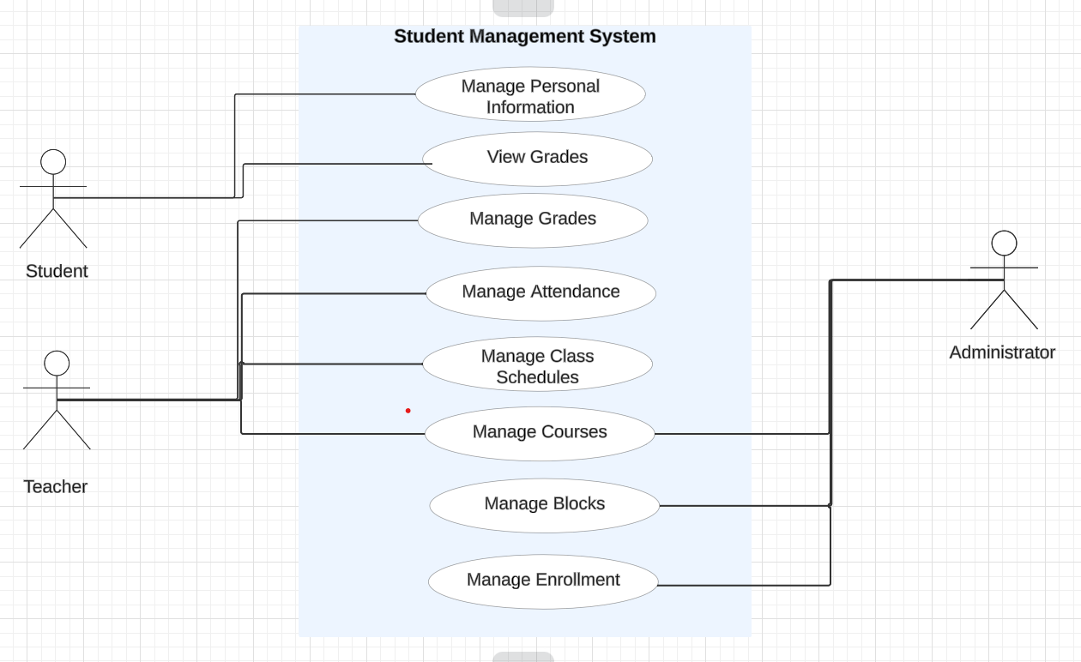

Retrieved from: <https://lucid.app/lucidchart/d4148ee5-d3fd-4378-a6e0-7220da95fc34/edit?page=.Q4MUjXso07N&invitationId=inv_ed4ac094-9a50-496a-9a8e-2b9b785d58ac#>

**FUNCTIONAL AND NON – FUNCTINAL :**

**Functional Requirements:**

* Ability to store and manage student information, including personal details academic courses and activities, and schedules. Use Cases ability to schedule classes and register student for classes.
* Ability to create and manage student and parent profiles, including their contact information.
* Ability to manage university activities and its instructors.
* Ability to provide a user- friendly interface for all system users.

**Non – functional requirements:**

* The system should handle many users and transactions efficiently.
* The system should be easy to update and maintain.
* Ensure integration with other systems such as academic record systems financial system.
* Implement backup and recovery solutions to prevent data loss.

What you did. Why you did it. Why is your implementation better. Your final system is probably different from your proposal – why?

Spend some time thinking about why you made the design choices that you did - there is no wrong answer here

List your use cases – these are implemented as queries in your system. **You need many (at least 12) -**

* Use case 1
* Use Case 2
* Use Case 3
* Etc…

# Entity Relationship Diagram

**You can add logical and physical ERD design (at least 5-6 entities) of your system here. Also briefly explain the relationships with cardinalities between entities in words.**

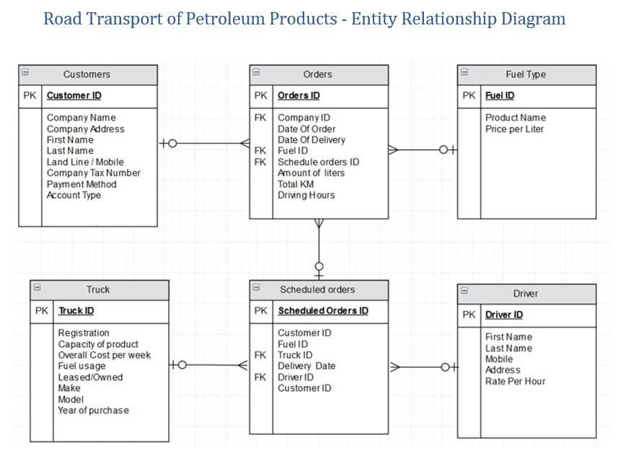

# Table Designs – Data Dictionary

**Add** **your data dictionary here (table structure for each table in your database)**

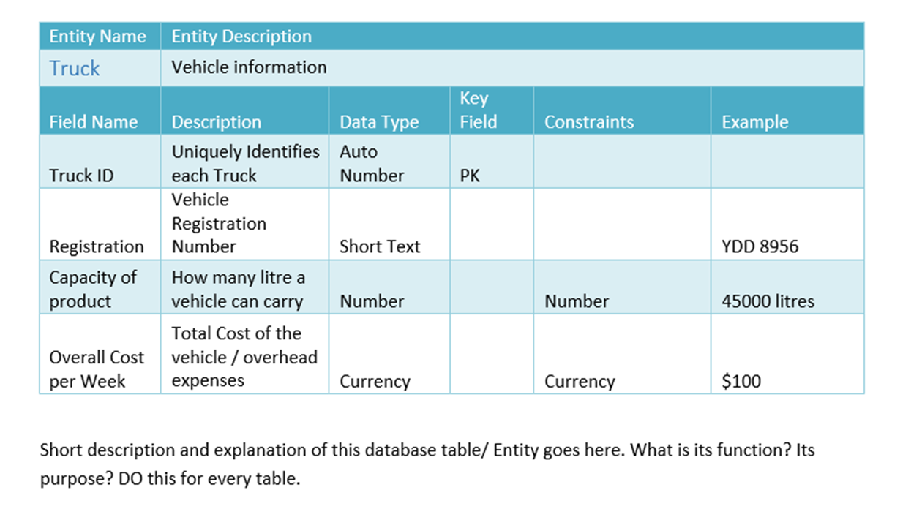







# Contributions

Add the list of members and their contributions to the project.

Also add the link to your GitHub Repository

# References

Add references here if you have any.